# JS Essentials - Exam Preparation

Exam problems for the [“JavaScript Essentials” course @ SoftUni](https://softuni.bg/courses/javascript-advanced). Submit your solutions in the SoftUni Judge system at <https://judge.softuni.bg/Contests/Practice/Index/1659#2>.

## Problem 3. Face Control

*Imagine you are a security guard in a disco. Your job is to check who goes in, who goes out and who has no permission to go in. You, as a smart person, decide to create a program which does it for you.*

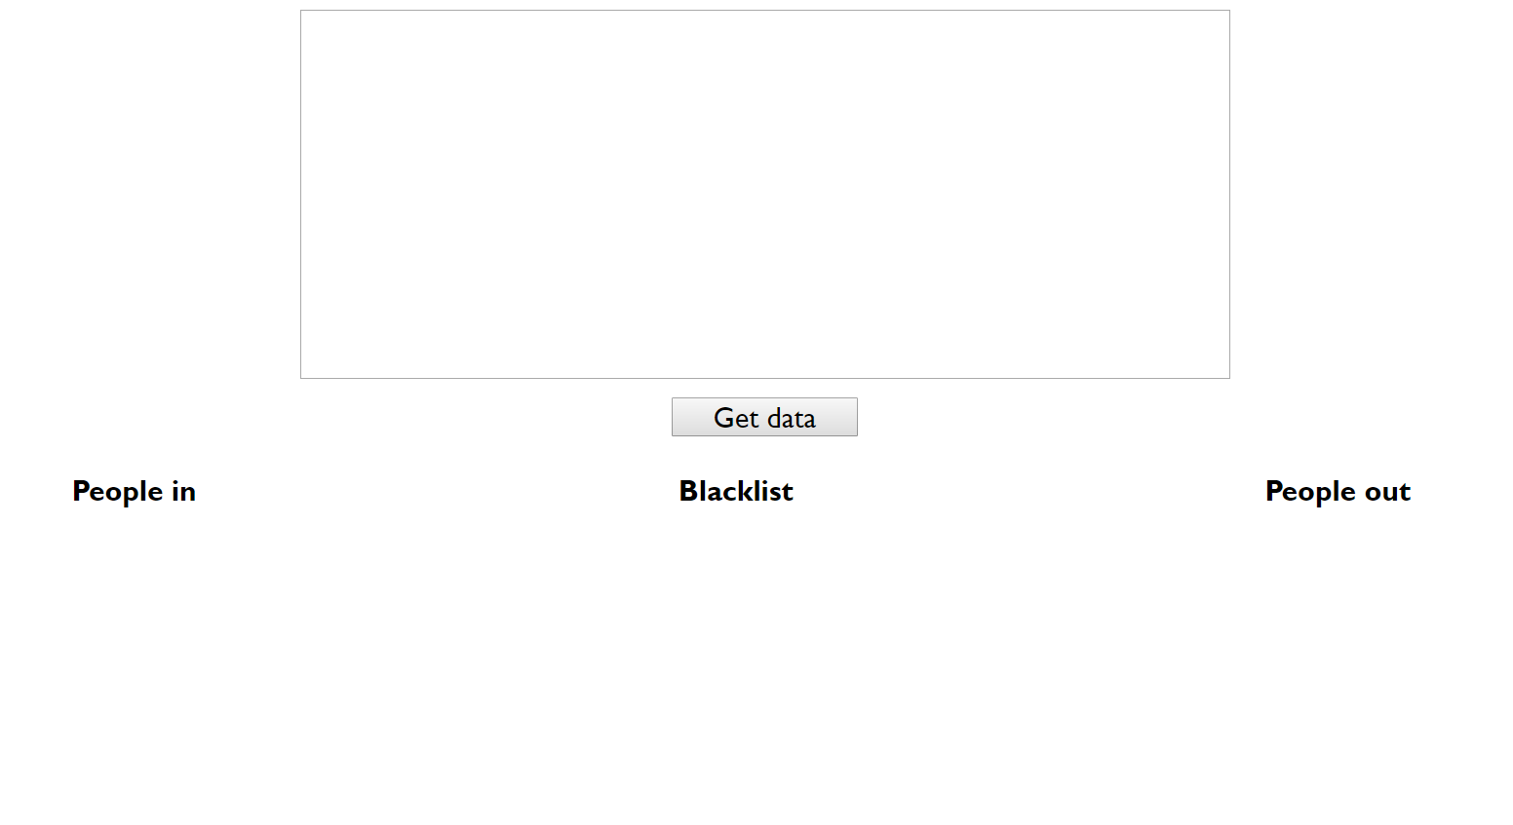

In this problem, you have to **manipulate** the **given input** and store the information in **different HTML elements**. Here is how it works:

The input is given in the **textarea** like a **value** and represents a **stringified** **array** of **objects**. Each object in that array has 3 properties (**firstName**, **lastName**, and **action**) **except** the **last object**.

The actions that every person can perform is:

* **peopleIn()** - That person **goes in** the club.
  + If that person has permission to go in the club, you have to put their **names** in the **People In** section (specifically in the paragraph)
* **peopleOut()** - That person **goes out** of the club.
  + If that person is already in the club, they go out of it. That means you have to **remove** them from the **people in list** and **put** **them** in the **people** **out** **list** (specifically in the paragraph).
* **blacklist()** - That person **no longer has permission** to go in the club
  + That person **goes** **to** **the** **blacklist** and has no longer permission to go in the club. If that person is already in the club, they **go out** (remove them from the **people in list** and put them in the **people out list**, specifically in the paragraph).

The **last element** in the array is an object with 2 properties (**criteria** and **action)**

* If the given criteria and action are **different than an empty string**, you must **sort all people** in that specific action (section) by the **given** **criteria** **alphabetically**.

### Input

**Array** of **objects** given like a value in the **textarea** element:

**[{"firstName":"Jon","lastName":"Snow","action":"peopleIn"},{"firstName":"Jonny","lastName":"Bravo","action":"peopleIn"},{"firstName":"John","lastName":"Doe","action":"peopleOut"},{"firstName":"Jon","lastName":"Snow","action":"peopleOut"},{"firstName":"John","lastName":"Doe","action":"peopleOut"},{"firstName":"Lenny","lastName":"Kravitz","action":"blacklist"},{"firstName":"Lenny","lastName":"Kravitz","action":"peopleIn"},{"firstName":"Marwin","lastName":"Athelstein","action":"peopleIn"},{"criteria":"lastName","action":"peopleIn"}]**

### Output

The output for each of the actions is the following format:

'**{"firstName":"{firstName}","lastName":"{lastName}"}** '

Note that after adding a person in some of the sections, you have to put an additional single space after.

In these cases when you have a **valid sorting criteria** and **action**, the objects in that specific section must be **sorted** **alphabetically** by the **given** **criteria**

### Constraints

* A valid sorting criteria will be either **firstName** or **lastName**
* A valid sorting section will be either **peopleIn**, **peopleOut** or **blacklist**
* Тhe elements of which you have to change the **textContent** are bordered with red in the picture below:

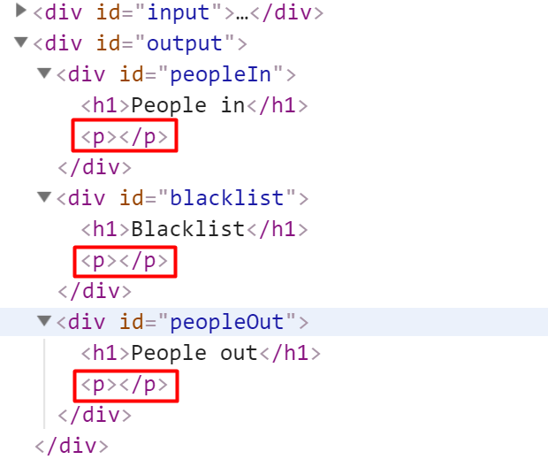

### Example

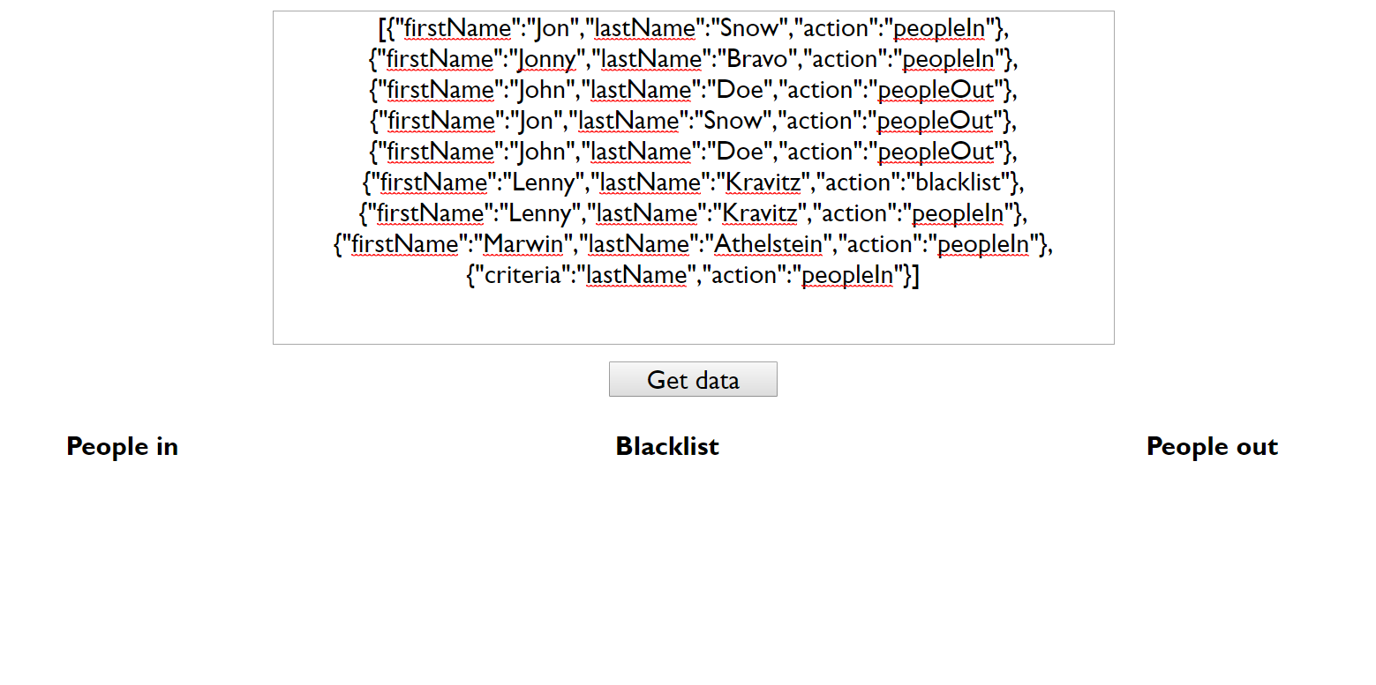

After clicking the [**Get** **data**] **button,** the expected result should be:

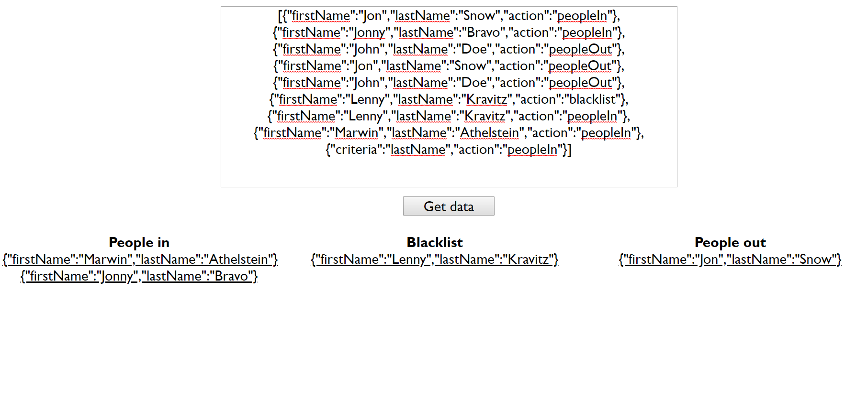

### Example

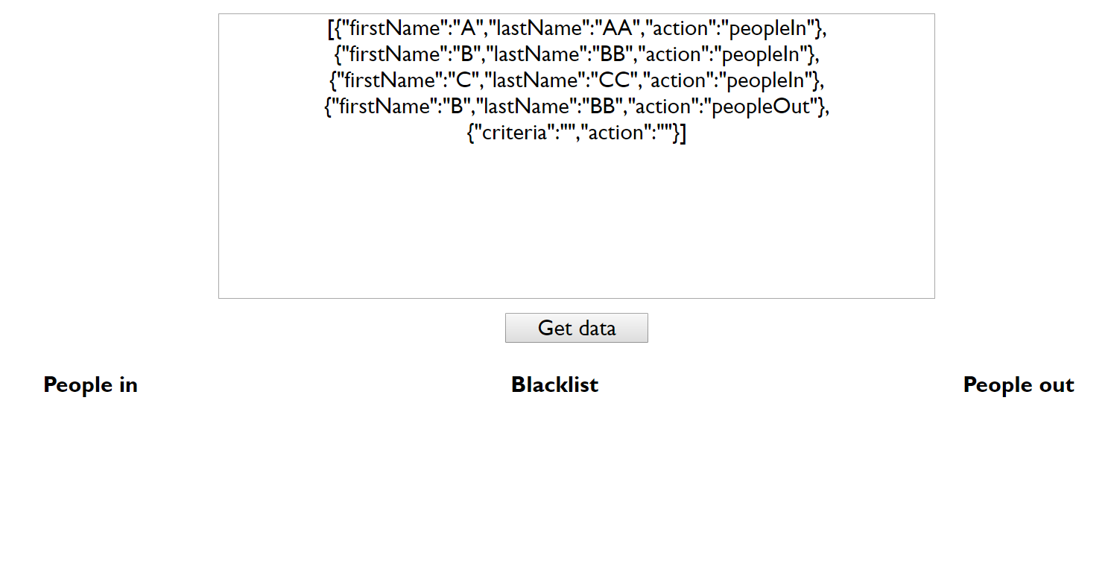

After clicking the [**Get** **data**] **button,** the expected result should be:

